Brown Clee C.E. Primary School
Accessibility
Plan
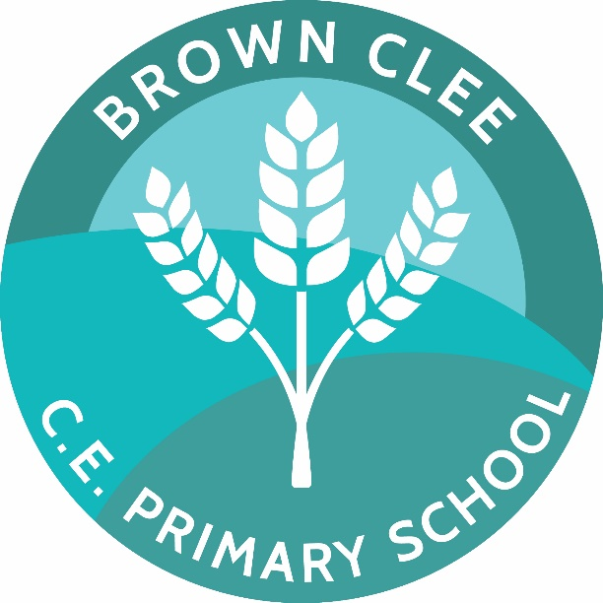

Most recently reviewed: Spring ‘26
Approved by governor: Jo Blakeman
Future review date: Spring ‘29

Contents
SUMMARY OF POLICY 2
Responsible individuals: 2
Relevant documentation used in the formation of this policy: 2
Policy developed to help ensure that… 3
Implementation: 3
Principles: 3
Action Plan: 4
Monitoring Arrangements: 5

SUMMARY OF POLICY

Responsible individuals:

Governing Body,
Headteacher,
SENDCo.,
Teachers,
Teaching Assistants,
Lunchtime Supervisors,
Administrator.

Relevant documentation used in the formation of this policy:
Equality Act (2010)
SEND Code of Practice – to 25 (2014)
Education Act (1996)
Children Act (1989)
DfE Guidance for Schools on Equality Act (2013)

Policy developed to help ensure that…
- …the extent to which pupils with disabilities can participate in the curriculum is maximised
- …the physical environment is continuously under review as to how it enables pupils with disabilities to take better advantage of the education, benefits, facilities and services provided
- …the availability of accessible information to pupils with disabilities

Implementation:
The school will…
- …ensure that all staff, governors, volunteers and visitors are aware of the following policy
- …ensure that the policy is followed at all times
- …ensure that any questions are raised with the headteacher if unsure about any aspects of the policy

Principles:
At Brown Clee CE Primary School, all members of staff are committed to ensuring that all pupils are treated fairly and with respect. This involves providing access and opportunities for all pupils without discrimination of any kind.
Our school’s Christian Values (Respect, Thankfulness, Perseverance, Forgiveness, Compassion and Courage) are integral to everything we do – including ensuring equality and inclusion.
It is unlawful for schools to discriminate against pupils on the grounds of sex, race, disability, religion or belief and sexual orientation, and this policy will be implemented at all times and adhered to by all staff, pupils, volunteers, parents/carers and visitors.
As based on the Equality Act (2010), a person has a disability if…
- …he or she has physical or mental impairment, and…
- …the impairment has a substantial and long-term adverse effect on his or her ability to carry out normal day-to-day activities
Under the SENDCo. of Practice, “long-term” is defined as “a year or more” and “substantial” is defined as “more than minor or trivial”. The definition includes sensory impairments, such as those affecting sight or hearing, and long-term health conditions (such as asthma, diabetes, epilepsy and cancer).
Brown Clee School is committed to providing an accessible environment which values and includes all pupils, staff, parents/carers, volunteers and visitors regardless of their education, physical, sensory, social, emotional and cultural needs. This will involve always actively challenging negative attitudes about disability and accessibility to develop a culture of awareness, tolerance and inclusion.
In circumstances where meeting a child’s need is proving difficult, advice will be sought by other professional bodies and/or the Local Authority.

Action Plan:
Aims | Current good practice | Objectives | Person(s) responsible
Increase the extent to which pupils with disabilities can participate in the curriculum | - Continuous review of needs of pupils – particularly in case new pupils and/or new diagnoses.  - Differentiated curriculum available (if required)  - Resources tailored to the needs of pupils who required support to access curriculum  - Curriculum progress tracked for all pupils – including those with a disability  - Target set, reviewed and amended (as required) for pupils with additional needs  - Continuous review of curriculum and its accessible | - To ensure lesson planning in all subjects always considers inclusion  - To raise staff awareness when addressing inclusion issues in all curriculum subjects to maintain an inclusive school culture  - To ensure inclusion is consider in all lesson observations | Headteacher  SLT  SENDCo.  Class teachers  Support Staff  Governors
Improve the physical environment to enable pupils with disabilities to take better advantage of the education, benefits, facilities and services provided | - Continuous review of needs of pupils – particularly in case new pupils and/or new diagnoses.  - Accessible entrances and exits around school  - Disabled toilers available  - Adjustable approach to access (where required) | - To ensure all entrances and exits are accessible by wheelchair (in the event of a user being present)  - To review the accessibility to all areas required within school  - To review the accessibility to all areas required in the outside space around school  - To develop a breakout space – which can be utilised by all pupils, but especially those with additional needs and/or disabilities | Headteacher  SLT  SENDCo.  Class teachers  Support Staff  Administrative Staff  Caretaker  Governors
Improve the availability of accessible information to pupils with disabilities | - Continuous review of needs of pupils – particularly in case new pupils and/or new diagnoses.  - Internal signage present around site  - Pictorial/symbolic representations used (where require) | - To investigate and develop information access arrangements, including internal and external signage – and continuing to review this  - To raise the awareness amongst staff of alternative technology and practices developed to assist those with additional need and/or disabilities | Headteacher  SLT  SENDCo.  Class teachers  Support Staff  Administrative Staff  Caretaker  Governors
Monitoring and evaluating this plan | - Accessibility plan fully reviewed every three years (as per recommendations) by headteacher  - Accessibility plan additionally reviewed annually by SENDCo.  - Accessibility plan reviewed in light of significant changes | - To carry out accessibility audit  - To carry out additional audits in light of any significant changes  - To raise awareness amongst staff of accessibility and its importance | Headteacher  SLT  SENDCo.  Class teachers  Governors

Monitoring Arrangements:
This document will be fully reviewed at a minimum of 3 years; however, an annual review will take place (and changes made – if necessary).
The annual review will be completed by the SENDCo. and the three-year review will be completed by the headteacher (alongside the SENDCo.) and further reviewed by the SEND-link governor.
Accessibility plan will be reviewed in light of any relevant and significant changes (e.g. new pupils with additional needs and/or disabilities, recent diagnoses of disability, significant changes to the school building/grounds or access arrangements, changes in leadership).

